COGNIZANT

Digital Nurture 4.0

Deep Skilling - Java FSE

WEEK-4 HANDS ON

By Kaviya P

1.SPRING-REST -HANDSON

**Hands on 1**

**Create a Spring Web Project using Maven**

Follow steps below to create a project: 

1. Go to <https://start.spring.io/>
2. Change Group as “com.cognizant”
3. Change Artifact Id as “spring-learn”
4. Select Spring Boot DevTools and Spring Web
5. Create and download the project as zip
6. Extract the zip in root folder to Eclipse Workspace
7. Build the project using ‘mvn clean package -Dhttp.proxyHost=proxy.cognizant.com -Dhttp.proxyPort=6050 -Dhttps.proxyHost=proxy.cognizant.com -Dhttps.proxyPort=6050 -Dhttp.proxyUser=123456’ command in command line
8. Import the project in Eclipse "File > Import > Maven > Existing Maven Projects > Click Browse and select extracted folder > Finish"
9. Include logs to verify if main() method of SpringLearnApplication.
10. Run the SpringLearnApplication class.

SME to walk through the following aspects related to the project created:

1. src/main/java - Folder with application code
2. src/main/resources - Folder for application configuration
3. src/test/java - Folder with code for testing the application
4. SpringLearnApplication.java - Walkthrough the main() method.
5. Purpose of @SpringBootApplication annotation
6. pom.xml
   1. Walkthrough all the configuration defined in XML file
   2. Open 'Dependency Hierarchy' and show the dependency tree.

**SpringLearnApplication.java**

**package** com.cognizant.spring_learn;

**import** org.springframework.boot.SpringApplication;

**import** org.springframework.boot.autoconfigure.SpringBootApplication;

@SpringBootApplication

**public** **class** SpringLearnApplication {

**public** **static** **void** main(String[] args) {

SpringApplication.*run*(SpringLearnApplication.**class**, args);

}

}

**Pom.xml**

<?xml version="1.0" encoding="UTF-8"?>

<project xmlns="http://maven.apache.org/POM/4.0.0" xmlns:xsi="http://www.w3.org/2001/XMLSchema-instance"

xsi:schemaLocation="http://maven.apache.org/POM/4.0.0 https://maven.apache.org/xsd/maven-4.0.0.xsd">

<modelVersion>4.0.0</modelVersion>

<parent>

<groupId>org.springframework.boot</groupId>

<artifactId>spring-boot-starter-parent</artifactId>

<version>3.5.3</version>

<relativePath/> <!-- lookup parent from repository -->

</parent>

<groupId>com.cognizant</groupId>

<artifactId>spring-learn</artifactId>

<version>0.0.1-SNAPSHOT</version>

<name>spring-learn</name>

<description>Demo project for Spring Boot</description>

<url/>

<licenses>

<license/>

</licenses>

<developers>

<developer/>

</developers>

<scm>

<connection/>

<developerConnection/>

<tag/>

<url/>

</scm>

<properties>

<java.version>17</java.version>

</properties>

<dependencies>

<dependency>

<groupId>org.springframework.boot</groupId>

<artifactId>spring-boot-starter-web</artifactId>

</dependency>

<dependency>

<groupId>org.springframework.boot</groupId>

<artifactId>spring-boot-starter-test</artifactId>

<scope>test</scope>

</dependency>

<dependency>

<groupId>org.springframework</groupId>

<artifactId>spring-context</artifactId>

</dependency>

</dependencies>

<build>

<plugins>

<plugin>

<groupId>org.springframework.boot</groupId>

<artifactId>spring-boot-maven-plugin</artifactId>

</plugin>

</plugins>

</build>

</project>

**OUTPUT :**

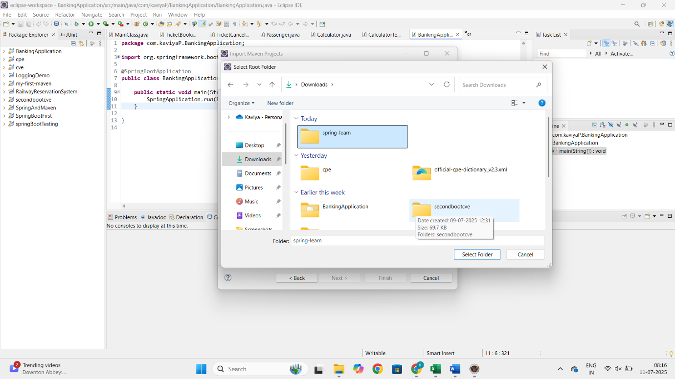

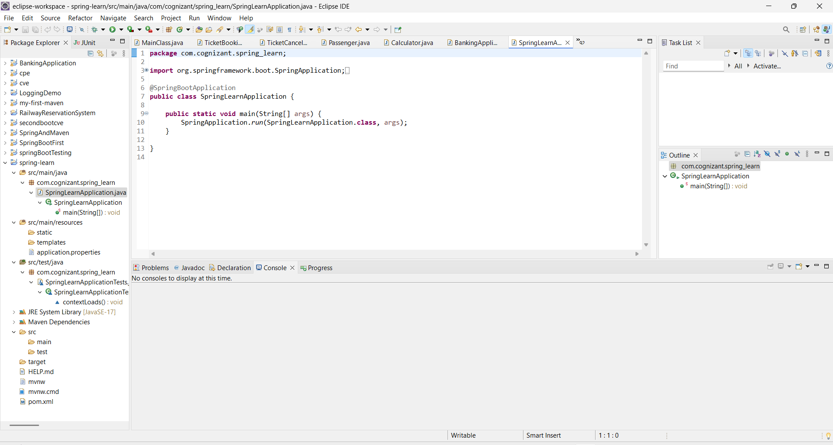

**Hands on 2**

**Spring Core – Load SimpleDateFormat from Spring Configuration XML**

**SpringLearnApplication.java**

**package** com.cognizant.spring_learn;

**import** java.text.SimpleDateFormat;

**import** java.util.Date;

**import** org.springframework.boot.SpringApplication;

**import** org.springframework.boot.autoconfigure.SpringBootApplication;

**import** org.springframework.context.ApplicationContext;

**import** org.springframework.context.support.ClassPathXmlApplicationContext;

@SpringBootApplication

**public** **class** SpringLearnApplication {

**public** **static** **void** main(String[] args) **throws** Exception{

SpringApplication.*run*(SpringLearnApplication.**class**, args);

*displayDate*();

}

**public** **static** **void** displayDate() **throws** Exception {

ApplicationContext context = **new** ClassPathXmlApplicationContext("date-format.xml");

SimpleDateFormat format = context.getBean("dateFormat", SimpleDateFormat.**class**);

Date date = format.parse("31/12/2018");

System.***out***.println("Parsed Date: " + date);

}

}

**OUTPUT :**

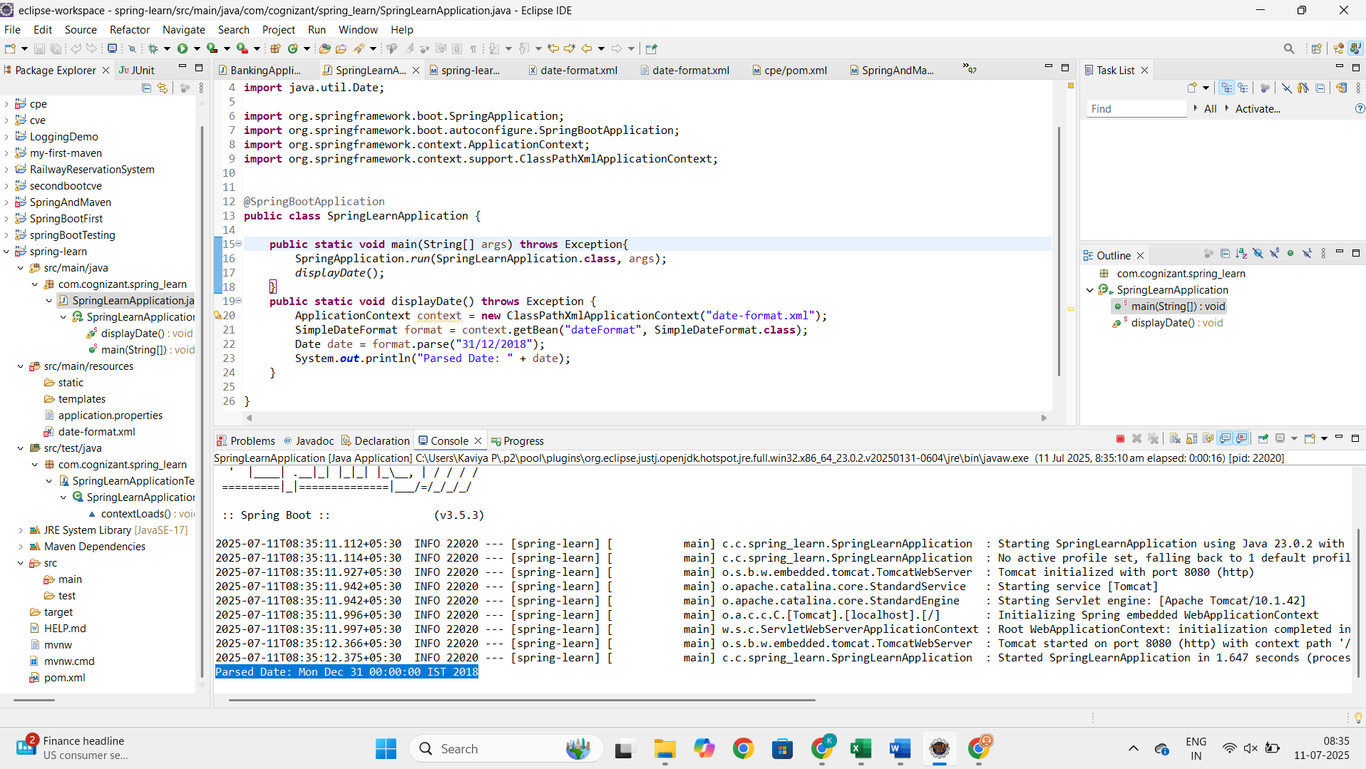

**Hands on 3**

**Spring Core - Incorporate Logging**

**SpringLearnApplication.java**  
  
**package** com.cognizant.spring_learn;

**import** java.text.SimpleDateFormat;

**import** java.util.Date;

**import** org.springframework.boot.SpringApplication;

**import** org.springframework.boot.autoconfigure.SpringBootApplication;

**import** org.springframework.context.ApplicationContext;

**import** org.springframework.context.support.ClassPathXmlApplicationContext;

**import** org.slf4j.Logger;

**import** org.slf4j.LoggerFactory;

@SpringBootApplication

**public** **class** SpringLearnApplication {

**private** **static** **final** Logger ***LOGGER*** = LoggerFactory.*getLogger*(SpringLearnApplication.**class**);

**public** **static** **void** main(String[] args) **throws** Exception{

SpringApplication.*run*(SpringLearnApplication.**class**, args);

*displayDate*();

}

**public** **static** **void** displayDate() **throws** Exception {

***LOGGER***.info("START");

ApplicationContext context = **new** ClassPathXmlApplicationContext("date-format.xml");

SimpleDateFormat format = context.getBean("dateFormat", SimpleDateFormat.**class**);

Date date = format.parse("31/12/2018");

***LOGGER***.debug("Parsed Date: {}", date);

***LOGGER***.info("END");

}

}

**Application.properties**

spring.application.name=spring-learn

logging.level.org.springframework=info

logging.level.com.cognizant.springlearn=debug

logging.pattern.console=%d{yyMMdd}|%d{HH:mm:ss.SSS}|%-20.20thread|%5p|%-25.25logger**{25}**|%25M|%m%n

**OUTPUT**

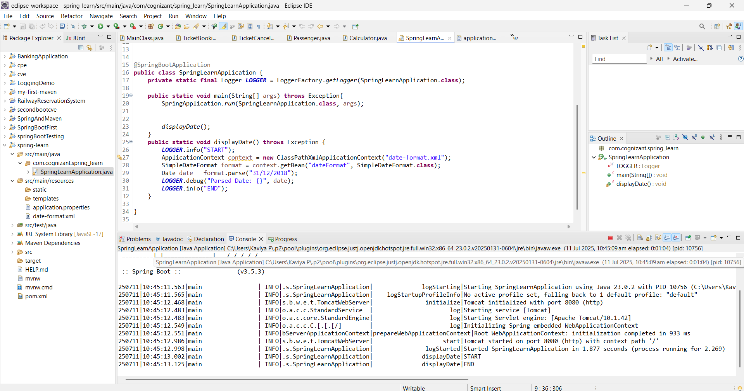

**Hands on 4**

**Spring Core – Load Country from Spring Configuration XML**

**SpringLearnApplication.java**

**package** com.cognizant.spring_learn;

**import** java.text.SimpleDateFormat;

**import** java.util.Date;

**import** org.springframework.boot.SpringApplication;

**import** org.springframework.boot.autoconfigure.SpringBootApplication;

**import** org.springframework.context.ApplicationContext;

**import** org.springframework.context.support.ClassPathXmlApplicationContext;

**import** org.slf4j.Logger;

**import** org.slf4j.LoggerFactory;

@SpringBootApplication

**public** **class** SpringLearnApplication {

**private** **static** **final** Logger ***LOGGER*** = LoggerFactory.*getLogger*(SpringLearnApplication.**class**);

**public** **static** **void** main(String[] args) **throws** Exception {

SpringApplication.*run*(SpringLearnApplication.**class**, args);

*displayCountry*();

}

**public** **static** **void** displayCountry() {

***LOGGER***.info("START");

ApplicationContext context = **new** ClassPathXmlApplicationContext("country.xml");

Country country = context.getBean("country", Country.**class**);

***LOGGER***.debug("Country : {}", country.toString());

***LOGGER***.info("END");

}

}

**Country.java**

**package** com.cognizant.spring_learn;

**import** org.slf4j.Logger;

**import** org.slf4j.LoggerFactory;

**public** **class** Country {

**private** **static** **final** Logger ***LOGGER*** = LoggerFactory.*getLogger*(Country.**class**);

**private** String code;

**private** String name;

**public** Country() {

***LOGGER***.debug("Inside Country Constructor.");

}

**public** String getCode() {

***LOGGER***.debug("Inside getCode()");

**return** code;

}

**public** **void** setCode(String code) {

***LOGGER***.debug("Inside setCode()");

**this**.code = code;

}

**public** String getName() {

***LOGGER***.debug("Inside getName()");

**return** name;

}

**public** **void** setName(String name) {

***LOGGER***.debug("Inside setName()");

**this**.name = name;

}

@Override

**public** String toString() {

**return** "Country [code=" + code + ", name=" + name + "]";

}

}

**pom.xml**

<?xml version="1.0" encoding="UTF-8"?>

<beans xmlns="http://www.springframework.org/schema/beans"

xmlns:xsi="http://www.w3.org/2001/XMLSchema-instance"

xsi:schemaLocation="http://www.springframework.org/schema/beans

https://www.springframework.org/schema/beans/spring-beans.xsd">

<bean id="country" class="com.cognizant.spring_learn.Country">

<property name="code" value="IN" />

<property name="name" value="India" />

</bean>

</beans>

**OUPUT**

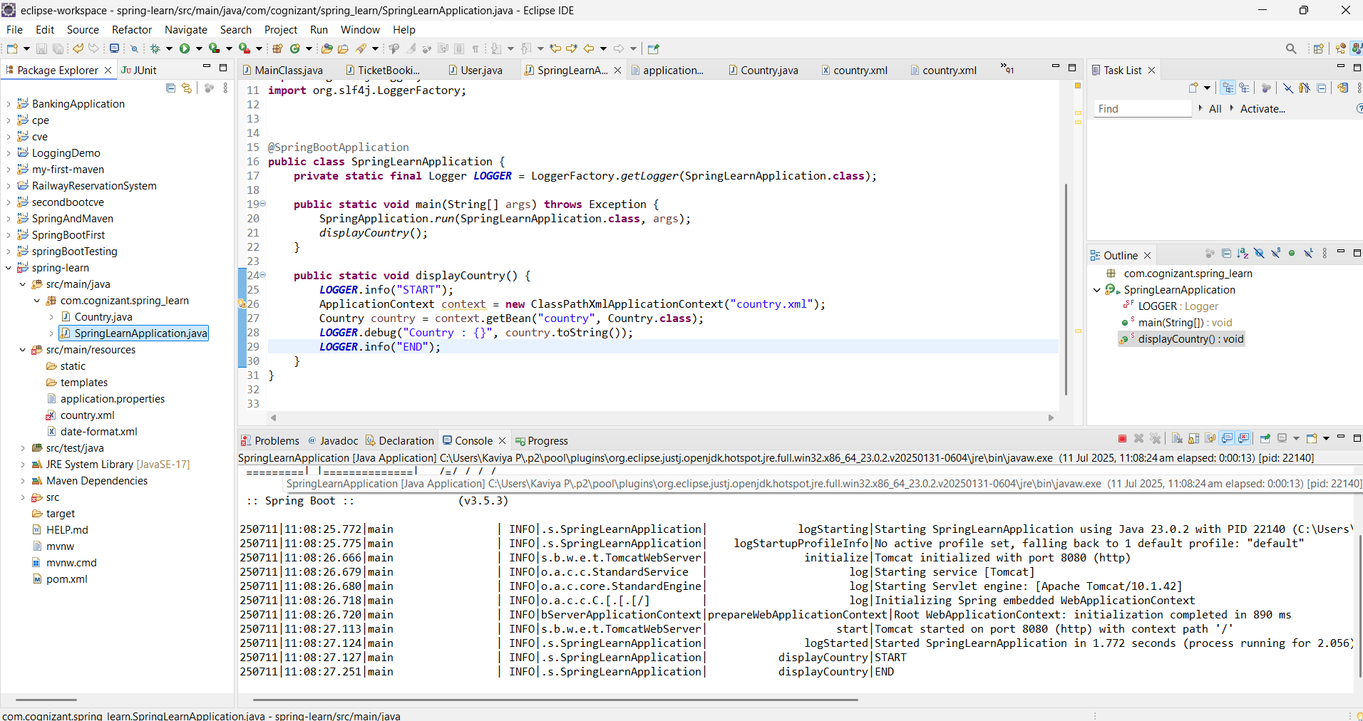

**Hands on 5**

**Spring Core – Demonstration of Singleton Scope and Prototype Scope**

**Country.java**

**package** com.cognizant.spring_learn;

**import** org.slf4j.Logger;

**import** org.slf4j.LoggerFactory;

**public** **class** Country {

**private** **static** **final** Logger ***LOGGER*** = LoggerFactory.*getLogger*(Country.**class**);

**private** String code;

**private** String name;

**public** Country() {

***LOGGER***.debug("Inside Country Constructor.");

}

**public** String getCode() {

***LOGGER***.debug("Inside getCode()");

**return** code;

}

**public** **void** setCode(String code) {

***LOGGER***.debug("Inside setCode()");

**this**.code = code;

}

**public** String getName() {

***LOGGER***.debug("Inside getName()");

**return** name;

}

**public** **void** setName(String name) {

***LOGGER***.debug("Inside setName()");

**this**.name = name;

}

@Override

**public** String toString() {

**return** "Country [code=" + code + ", name=" + name + "]";

}

}

**SpringLearnApplication.java**

**package** com.cognizant.spring_learn;

**import** java.text.SimpleDateFormat;

**import** java.util.Date;

**import** org.springframework.boot.SpringApplication;

**import** org.springframework.boot.autoconfigure.SpringBootApplication;

**import** org.springframework.context.ApplicationContext;

**import** org.springframework.context.support.ClassPathXmlApplicationContext;

**import** org.slf4j.Logger;

**import** org.slf4j.LoggerFactory;

@SpringBootApplication

**public** **class** SpringLearnApplication {

**private** **static** **final** Logger ***LOGGER*** = LoggerFactory.*getLogger*(SpringLearnApplication.**class**);

**public** **static** **void** main(String[] args) **throws** Exception {

SpringApplication.*run*(SpringLearnApplication.**class**, args);

*displayCountry*();

}

**public** **static** **void** displayCountry() {

***LOGGER***.info("START");

ApplicationContext context = **new** ClassPathXmlApplicationContext("country.xml");

Country country = context.getBean("country", Country.**class**);

Country anotherCountry = context.getBean("country", Country.**class**);

***LOGGER***.debug("Country: {}", country);

***LOGGER***.debug("Another Country: {}", anotherCountry);

***LOGGER***.info("END");

}

}

**Country.xml**

<?xml version="1.0" encoding="UTF-8"?>

<beans xmlns="http://www.springframework.org/schema/beans"

xmlns:xsi="http://www.w3.org/2001/XMLSchema-instance"

xsi:schemaLocation="http://www.springframework.org/schema/beans

https://www.springframework.org/schema/beans/spring-beans.xsd">

<bean id="country" class="com.cognizant.springlearn.Country">

<property name="code" value="IN" />

<property name="name" value="India" />

</bean>

</beans>

**OUTPUT**

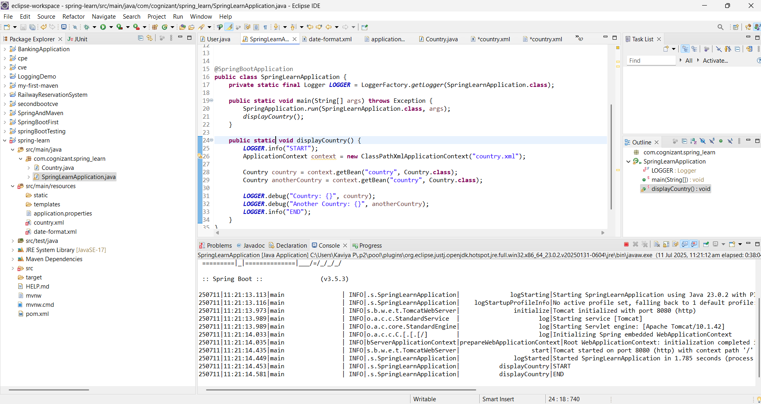

**Hands on 6**

**Spring Core – Load list of countries from Spring Configuration XML**

**Country.java**

**package** com.cognizant.spring_learn;

**import** org.slf4j.Logger;

**import** org.slf4j.LoggerFactory;

**public** **class** Country {

**private** **static** **final** Logger ***LOGGER*** = LoggerFactory.*getLogger*(Country.**class**);

**private** String code;

**private** String name;

**public** Country() {

***LOGGER***.debug("Inside Country Constructor.");

}

**public** String getCode() {

***LOGGER***.debug("Inside getCode()");

**return** code;

}

**public** **void** setCode(String code) {

***LOGGER***.debug("Inside setCode()");

**this**.code = code;

}

**public** String getName() {

***LOGGER***.debug("Inside getName()");

**return** name;

}

**public** **void** setName(String name) {

***LOGGER***.debug("Inside setName()");

**this**.name = name;

}

@Override

**public** String toString() {

**return** "Country [code=" + code + ", name=" + name + "]";

}

}

**SpringLearnApplication.java**

**package** com.cognizant.spring_learn;

**import** java.text.SimpleDateFormat;

**import** java.util.Date;

**import** java.util.List;

**import** org.springframework.boot.SpringApplication;

**import** org.springframework.boot.autoconfigure.SpringBootApplication;

**import** org.springframework.context.ApplicationContext;

**import** org.springframework.context.support.ClassPathXmlApplicationContext;

**import** org.slf4j.Logger;

**import** org.slf4j.LoggerFactory;

@SpringBootApplication

**public** **class** SpringLearnApplication {

**private** **static** **final** Logger ***LOGGER*** = LoggerFactory.*getLogger*(SpringLearnApplication.**class**);

**public** **static** **void** main(String[] args) **throws** Exception {

SpringApplication.*run*(SpringLearnApplication.**class**, args);

*displayCountry*();

*displayCountries*();

}

**public** **static** **void** displayCountry() {

***LOGGER***.info("START");

ApplicationContext context = **new** ClassPathXmlApplicationContext("country.xml");

Country country = context.getBean("in", Country.**class**);

Country anotherCountry = context.getBean("in", Country.**class**);

***LOGGER***.debug("Country: {}", country);

***LOGGER***.debug("Another Country: {}", anotherCountry);

***LOGGER***.info("END");

}

**public** **static** **void** displayCountries() {

***LOGGER***.info("START");

ApplicationContext context = **new** ClassPathXmlApplicationContext("country.xml");

@SuppressWarnings("unchecked")

List<Country> countryList = (List<Country>) context.getBean("countryList");

***LOGGER***.debug("Country List: {}", countryList);

***LOGGER***.info("END");

}

}

**Country.xml**

<?xml version="1.0" encoding="UTF-8"?>

<beans xmlns="http://www.springframework.org/schema/beans"

xmlns:xsi="http://www.w3.org/2001/XMLSchema-instance"

xsi:schemaLocation="http://www.springframework.org/schema/beans

https://www.springframework.org/schema/beans/spring-beans.xsd">

<bean id="in" class="com.cognizant.spring_learn.Country">

<property name="code" value="IN" />

<property name="name" value="India" />

</bean>

<bean id="us" class="com.cognizant.spring_learn.Country">

<property name="code" value="US" />

<property name="name" value="United States" />

</bean>

<bean id="de" class="com.cognizant.spring_learn.Country">

<property name="code" value="DE" />

<property name="name" value="Germany" />

</bean>

<bean id="jp" class="com.cognizant.spring_learn.Country">

<property name="code" value="JP" />

<property name="name" value="Japan" />

</bean>

<!-- List bean -->

<bean id="countryList" class="java.util.ArrayList">

<constructor-arg>

<list>

<ref bean="in"/>

<ref bean="us"/>

<ref bean="de"/>

<ref bean="jp"/>

</list>

</constructor-arg>

</bean>

</beans>

**OUTPUT**

